**Q11. Configure a standard Access Control List (ACL) on a router to permit traffic from a specific IP range. Test connectivity to verify the ACL is working as intended.**

**Configuring router:**

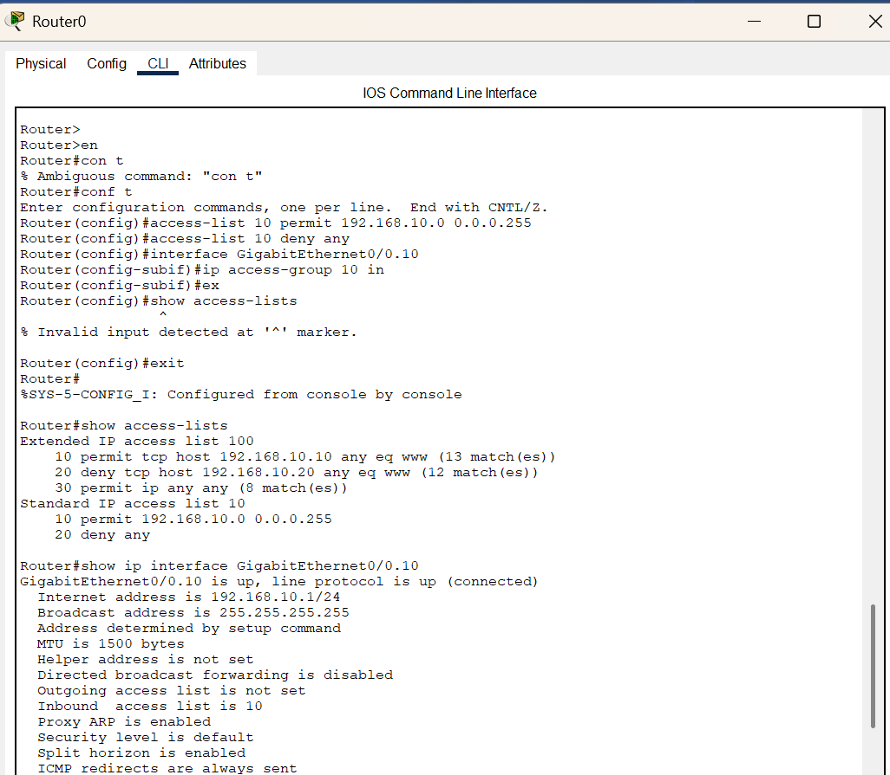

**To check connectivity On PC1 (192.168.10.10):**

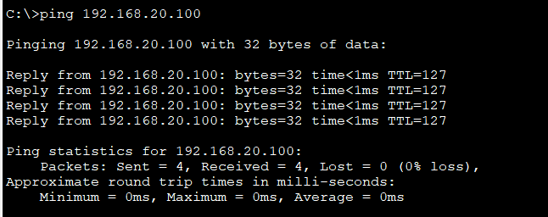

**To check connectivity On PC1 (192.168.10.10):**

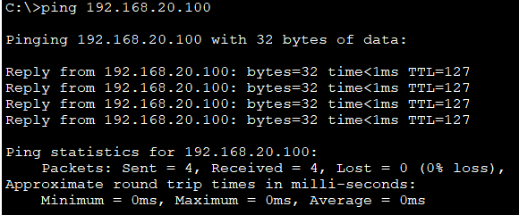

**Test Command from Server (192.168.20.100) to PC1 (192.168.10.10) -telnet and ssh:**

